Name | Age | Blurb
The Grand Wolf | 4 to 7 | Wolfgang and his friends love to visit The Grand Wolf but one day they arrive to find that he has gone and this makes them all feel very sad. Spider shows Wolfgang that by just seeing things a little differently he can feel happy again, knowing that true love never ends. Our lives are in a constant state of change and only we can ever know how big each change feels to us. The more we can talk about and embrace change, the better we get at it (whatever shape or size it comes in).
Is Daddy Coming Back in a Minute? | 3 to 7 | When we were on a No Girls Allowed! holiday, my daddy's heart stopped beating and I had to find help all by myself. He was very badly broken. Not even the ambulance people could help him...Written in Alex's own words, it is based on the real-life conversations that Elke Barber had with her then three-year-old son, Alex, after the sudden death of his father. The book provides reassurance and understanding to readers through clear and honest answers to the difficult questions that can follow the death of a loved one, and carries the invaluable message that it is okay to be sad, but it is okay to be happy, too.
What Happened To My Daddy's Body? | 3 to 7 | My daddy died when I was (one...two...) three years old. Today we are out in the garden. It always makes me think about my daddy because he LOVED his garden. Sometimes, I wonder what happened to my daddy's body... Through telling the true story of what happened to his daddy's body, we follow Alex as he learns about cremation, burial and spreading ashes. Full of questions written in Alex's own words, and with the gentle, sensitive and honest answers of his mother, this story will reassure any young child who might be confused about death and what happens afterwards. It also reiterates the message that when you have experienced the loss of a loved one, it is okay to be sad, but it is okay to be happy, too.
When Someone Special Dies | 9 to 12 | A practical format for allowing children to understand the concept of death and develop coping skills for life, this book is designed for young readers to illustrate.
Someone Has Died in a Road Crash | All | A sudden death in a road crash is one of the worst deaths of all. Particularly if you are a child and it was your mum, dad, sister or brother who died. Someone has died in a road crash is a children's book for all ages, taking children step by step through practical things such as funerals and police investigations and exploring normal emotions and feelings. The book is colourful and is narrated by two children who have been bereaved in a road crash who give caring and helpful tips. The book is meant to be read by a child with a parent or carer.
Muddles, Puddles and Sunshine | 5 to 7 | Muddles, Puddles and Sunshine offers practical and sensitive support for bereaved children. Beautifully illustrated, it suggests a helpful series of activities and exercises accompanied by the friendly characters of Bee and Bear. This book offers a structure and an outlet for the many difficult feelings which inevitably follow when someone dies. It aims to help children make sense of their experience by reflecting on the different aspects of their grief, whilst finding a balance between remembering and having fun. This book is a useful companion in the present, and will become an invaluable keepsake in the years to come.
Always and Forever | 3 to 6 | When Fox dies the rest of his family are absolutely distraught. How will Mole, Otter and Hare go on without their beloved friend? But, months later, Squirrel reminds them all of how funny Fox used to be, and they realise that Fox is still there in their hearts and memories.
Badgers Parting Gifts | 0 to 5 | Badger is so old that he knows he must soon die, so he does his best to prepare his friends. When he finally passes away, they are grief-stricken, but one by one they remember the special things he taught them during his life. By sharing their memories, they realise that although Badger is no longer with them physically, he lives on through his friends.
When Someone Has a Very Serious Illness | 9 to 12 | This book will help families communicate and evaluate a child's understanding and feelings about family change while teaching basic concepts of illness and healthy coping skills.
Missing Mummy | 3 to 7 | this extraordinary book deals with the loss of a parent from a child's point of view. Perfectly pitched text and evocative artwork explore the many emotions a bereaved child may experience, from anger to guilt and from sadness to bewilderment. And importantly, the book also focuses on the positive - the recognition that the child is still part of a family, and that his memories of his mother are to be treasured. Beautifully illustrated with moments of wonderful warmth and the gentlest humour, Missing Mummy is a touching, honest and helpful book that approaches a difficult subject with great integrity.
I Miss My Sister |  | Written and designed by Sarah Courtauld and beautifully illustrated by Holly Surplice. A story book with expressive and colourful illustrations to help guide children through the range of emotions they may experience over time, following the death of a sibling.
Tell Me About Heaven Grandpa Rabbit |  | This gentle and uplifting story is designed to help young children come to terms with losing someone special.
Are You A Sad Little Bear? | 3-6 yrs | The book follows the story of Bradley Bunny and his grandfather, Grandpa Rabbit. When Bradley asks Grandpa Rabbit what heaven is like, Grandpa asks Bradley to imagine 'a place in the sky that feels special'. Bradley Bunny imagines a carrot themed funfair in the sky! Grandpa Rabbit says that he imagines a beautiful garden, full of old friends and delicious food. Either way, when Grandpa Rabbit eventually goes to Heaven, Bradley is secure in the knowledge that that Grandpa will be very happy there. At the beginning of the story, Grandpa Rabbit had given Bradley a gift. At the end of the story, this gift reappears, and serves as a moving reminder to Bradley that, whilst the grandpa he loves has left, in some way, he will always be with him.
Rabbityness | 3-8 yrs | Rabbit enjoys doing rabbity things, but he also loves un-rabbity things! When Rabbit suddenly disappears, no one knows where he has gone. His friends are desolate. But, as it turns out, Rabbit has left behind some very special gifts for them, to help them discover their own unrabbity talents! This is a stunning debut picture book by author/illustrator Jo Empson. Rabbityness celebrates individuality, encourages the creativity in everyone and positively introduces children to dealing with loss of any kind.
We Were Gonna Have A Baby But Had An Angel Instead | 2-4 yrs | A small boy gazes into an empty bassinet on the cover of this psychologically astute book, which helps children cope with prenatal death or stillbirth. The narrator briefly recalls how he had looked forward to having a sibling, imagining the two of them "building a fort and playing tricks on our parents," and recalling how he had loved listening to the baby inside his mother. "But something happened," he reports, his trusty basset hound mirroring his sad, dejected expression. "The baby died. Our baby is not going to live with us."
Remembering |  | A beautiful keepsake/memory book for children when someone special in their life has died. It has been written by Dianne Leutner. The outstanding illustrations by award-winning Daniel Postgate are light-hearted yet thoughtful.
Waterbugs and Dragonflies |  | How can we answer the many questions young children have about death? Looking for a meaningful way to explain to neighbourhood children the death of a five-year-old friend, Doris Stickney adapted the graceful fable about the waterbug that changed into a dragonfly. First published under the title "Death" in 'Colloquy' (December 1971), the story was revised and expanded in 1982 to become the current bestselling Waterbugs and Dragonflies.
The Little Book of Bereavement for Schools |  | The Little Book of Bereavement for Schools is written by best-selling author Ian Gilbert together with his three children. It is a very personal account of the way educational institutions tried and succeeded, tried and failed and sometimes didn t try at all to help William, Olivia and Phoebe come to terms with the death of their mother. Several months after their mother s death BBC s Newsround aired a brave and still controversial programme in which four children talked about their losses. This prompted Ian and his children to sit down and think about their own experiences and draw up a list of dos and don ts that could help steer schools - and indeed all professionals working with children - towards a better understanding of what is needed from them at such a difficult time. The warmth of reception of this initial fifteen-point handout led the family to expand their advice and suggestions into what has now become The Little Book of Bereavement for Schools, the proceeds of which will go to Nicky s Way in Suffolk.
Someone Has Died Suddenly |  | This colourful book, prepared in partnership with bereavement specialists, is for suddenly bereaved children and adults to read together. It helps children understand their strong feelings and gives suggestions to help them cope.
Waterbugs and Dragonflies Colouring Book | 4-8yrs | The Pilgrim Press introduces its perennial bestseller "Water Bugs and Dragonflies: Explaining Death to Young Children" by Doris Stickney in coloring book format.
The Invisible String | 3-6 yrs | Parents, educators, therapists, and social workers alike have declared The Invisible String the perfect tool for coping with all kinds of separation anxiety, loss, and grief. In this relatable and reassuring contemporary classic, a mother tells her two children that they're all connected by an invisible string. "That's impossible!" the children insist, but still they want to know more: "What kind of string?" The answer is the simple truth that binds us all: An Invisible String made of love. Even though you can't see it with your eyes, you can feel it deep in your heart, and know that you are always connected to the ones you love. Does everybody have an Invisible String? How far does it reach? Does it ever go away? This heartwarming picture book for all ages explores questions about the intangible yet unbreakable connections between us, and opens up deeper conversations about love.
The Memory Tree | 3-6 yrs | Fox has lived a long and happy life in the forest, but now he is tired. He lies down in his favourite clearing, and falls asleep for ever. Before long, Fox's friends begin to gather in the clearing. One by one, they tell stories of the special moments that they shared with Fox. And so, as they share their memories, a tree begins to grow, becoming bigger and stronger with each memory, sheltering and protecting all the animals in the forest, just as Fox did when he was alive.
The Memory Box | 4-8 yrs | From the perspective of a young child, author Joanna Rowland artfully describes what it's like to remember and grieve a loved one who has died. The child in the story wonders if she will forget the person who has gone. Other days I wonder if I’ll ever stop feeling sad you are gone. The main character creates a memory box to keep mementos and written memories of her loved one to help with the grieving process. Throughout the narrative, the child's feelings are acknowledged, allowed, and assured that feelings are normal and healthy to express. Heartfelt and comforting, The Memory Box helps children, parents, educators, therapists, and social workers talk about this very difficult topic together. The unique point of view allows each reader to imagine the loss of someone they've loved -- a friend, family member, or even a pet. A guide in the back includes information to help children manage grief and offers suggestions on how to create a memory box.
Far Down Deep |  | Grief is unique. It can be frightening and lonely. It can make you feel everything and nothing and it is deeply personal. Come with us on a journey 'Far Down Deep' as one young person descends through the surreal and bittersweet nightmare of grieving to reach what is locked away from the world: the inexpressible burden of loss, which might just be a little lighter when - with a little support - some of it is set free... With words by Nik Larcombe and stunning illustrations by Craig Dixon, 'Far Down Deep' is dedicated to all of those who have grieved like children for someone close.
I Miss You: First Look At Death |  | When a close friend or family member dies, it can be difficult for children to express their feelings. This book helps children understand that death is a part of life. Thomas, a psychotherapist and counselor, promotes positive interaction among children, parents, and teachers. Full-color illustrations.
The Goodbye Book | 3 - 6 yrs | Through the lens of a pet fish who has lost his companion, Todd Parr tells a moving and wholly accessible story about saying goodbye. Touching upon the host of emotions children experience, Todd reminds readers that it's okay not to know all the answers and that someone will always be there to support them. An invaluable resource for life's toughest moments.
The Sad Book - Michael Rosen | 7 years + | Very occasionally the term non-fiction has to stretch itself to accommodate a book that fits into no category at all. Michael Rosen's Sad Book is such a book. It chronicles Michael's grief at the death of his son Eddie from meningitis at the age of 19. A moving combination of sincerity and simplicity, it acknowledges that sadness is not always avoidable or reasonable and perfects the art of making complicated feelings plain. It wasn't made like any other book either; Michael Rosen said of the text, " I wrote it at a moment of extreme feeling and it went straight down onto the page ... Quentin didn't illustrate it, he 'realized' it. He turned the text into a book and as a result showed me back to myself. No writer could ask and get more than that." And Quentin Blake says that the picture of Michael "being sad but trying to look happy" is the most difficult drawing he's ever done... "a moving experience."
The Little Flower Bulb |  | The Little Flower Bulb tells the story of Jamie, his mom, and his twin sisters, and of how Jamie comes to deal with the death of his father. Suitable for children aged 3-10, this beautifully illustrated book will be helpful for parents when talking to children bereaved by the suicide of a close relative.
Basil |  | Basil is a border collie. Basil is staying at The Little Paws Hotel for two weeks. During his time here a very special friend, Buddy, dies peacefully of old age at the vet's. Basil feels lots if different emotionsas he spends the rest of his stay without Buddy. Let's find out how he gets on...
You Will Be Ok | 10yrs + | The death of a parent, sibling or friend is one of the most traumatic experiences for a child or young person and it can be hard to know how to talk to them about it. In this honest, comforting and strength-building guide Julie Stokes, a clinical psychologist and founder of childhood bereavement charity Winston's Wish, provides readers with the tools they need to navigate this tough and turbulent time.
Tough Stuff Journal | 9-13yrs | This is aimed at supporting young people wrestling with the loss of someone close. The journal is designed to be used by a young person accompanied by a trusted adult - a parent or relative, youth worker, social worker or school mentor. The journal is designed deliberately in 'free form', can be written in and asks open questions to encourage the young person to reflect on and record their feelings about the loss.
The Day the sea went out and never come back |  | The Day the Sea Went Out and Never Came Back is a story for children who have lost someone they love. Eric is a sand dragon who loves the sea very much. Each day, he watches it going out and coming back. His sea is beautiful indeed to him. But one day, the sea goes out and does not come back. Eric waits and waits, but it does not come back. So he falls on the sand in terrible pain. It feels to him as if he has lost everything.
My Brother and Me | 4yrs + | This book is written by Sarah Courtauld, and beautifully illustrated by Rebecca Cobb. The simple story deals with issues surrounding a sibling's serious illness, and stays in hospital, and how his brother copes with different emotions and feelings. It is for children aged 4 - 10 years old. This book received a 'Commended' BMA Patient Information award.
Sad Isn't Bad | 8-12 yrs | Here is the book that Elf-help fans everywhere were asking for . . . a book to help children grieve in healthy ways. This friendly and loving guide is loaded with positive, life-affirming help to coping with loss as a child.
Help Me Say Goodbye |  | An art therapy and activity book for children coping with death. Sensitive exercises address all the questions children may have during this emotional and troubling crisis. Children are encouraged to express in pictures what they are often incapable of expressing in words.
The Lonely Tree |  | Universally praised and beautifully written and illustrated, 'The Lonely Tree' follows the first year in the life of a lone evergreen growing in the heart of the ancient oak woodland of the New Forest. The evergreen is befriended by the oldest oak who has lived for hundreds of years. When winter arrives all the oak trees must go to sleep, but of course evergreens never sleep. Finally, after a long, cold and lonely winter, spring brings both sadness and joy to the little tree. The Lonely Tree is a charmingly illustrated picture book which will help children and their families in times of loss or change with the gentle reassurance that saying goodbye is a natural part of life. Join the old oak, barn owl, ponies and squirrels in this enchanting, life affirming modern classic.
Remembering Mummy Memory Book |  | A book for small children who lose their mother, Remembering Mummy: A Memory Book provides questions to be answered by those who remember her, prompts for drawings and photographs, and quotes about loss and bereavement. A touching and wonderful way to help grieving children to remember their lost parent, Remembering Mummy provides a lasting source of information and memories for children to cherish as they grow older.
Remembering Daddy Memory Book |  | A book for small children who lose their father, Remembering Daddy: A Memory Book provides questions to be answered by those who remember him, prompts for drawings and photographs, and quotes about loss and bereavement. A touching and wonderful way to help grieving children to remember their lost parent, Remembering Daddy provides a lasting source of information and memories for children to cherish as they grow older.
The Tell-me Tree | 4-7yrs | Beautifully illustrated, this gentle picture book invites children to share how they are feeling – whether happy, sad or anywhere in between, through conversation, drawings or writing. Includes download links to a choice of Tell-Me Tree posters for use at home or in the classroom (including one where children can add their own friends or family beneath the tree), fun templates to help children draw their own tree, and links to resources for grown-ups.
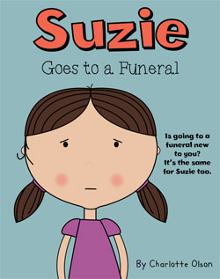 | 3-7 yrs | Suzie's first time at a funeral.  An anxious time for anybody.  Join Suzie as she says goodbye to Grandma.  A book to help any child help understand the process of a funeral and to show that they will live on in our memories forever.
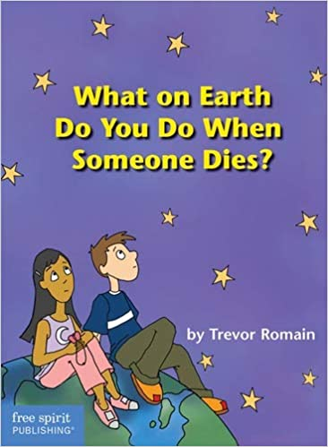 | 6-9 yrs | This book can help you through a painful time. Trevor answers questions you might wonder about--''Why do people have to die?''''Is the death my fault?''''What happens to the person's  body?''''How can I say good-bye?--in simple, honest words. He describes the strong, confusing feelings you might have and suggests ways to feel better. He tells you it's okay to cry, talk about the death, grieve ... and go on with your life
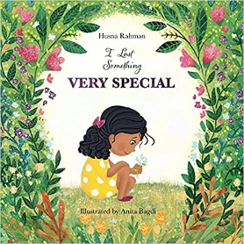 | 3-7 yrs | Losing things can be hard but it's always exciting when we find them again!  But what happens when we lose something we can never get back?  A little girl shares some of her fondest memories as she tries to make sense of losing something very, very special.  This book is centred around loss and grief for children
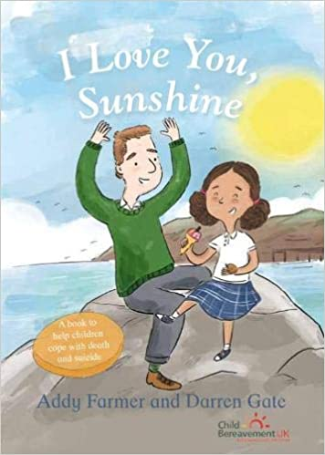 | 5-11 yrs | 'I love you, Sunshine' tells the story of how one dad dies by suicide and how it affects his eight year old daughter, Milly, and the rest of her family. It is a story of bereavement but it is also a story of love. It is intended as a way for all families bereaved by suicide to know that they are not alone; to build resilience through understanding; and to help take small steps forwards.
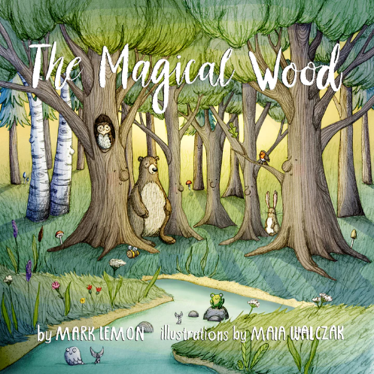 | 5-11 yrs | This is a story about loss, friendship and hope. The Magical Wood, is set in a beautiful wood with a river wandering through. One cold and stormy day, the wind blew a terrible gale. The next day the tree family woke to find that Strongest Tree had fallen to the woodland floor and had sadly died. How would the tree family survive the seasons without the strength of Strongest Tree?
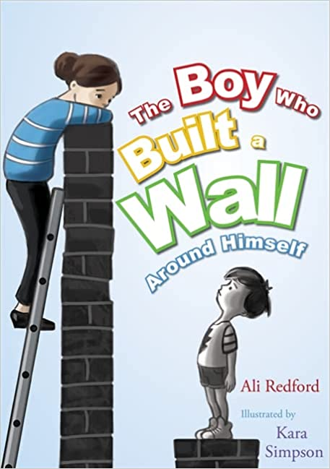 | 4-9 yrs | Boy built a wall to keep himself safe. Behind it he felt strong and more protected. Then Someone Kind came along. She bounced a ball, sang and painted on the other side of the wall, and Boy began to wonder if life on the other side might be better after all.  This gentle full-colour picture book uses a simple metaphor to explain how children who have had painful or traumatic experiences can build barriers between themselves and other people. It will help children explore their feelings and encourage communication.
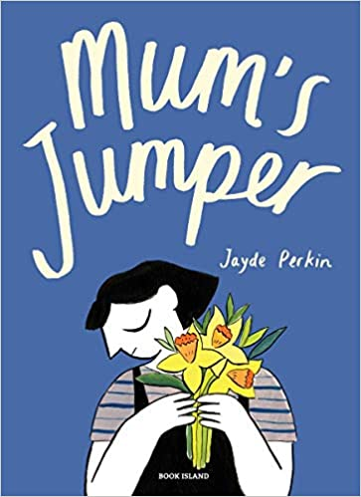 | 5-11 yrs | If Mum has gone, how do you carry on? Missing her feels like a dark cloud that follows you around,or like swimming to a shore that never comes any nearer. But memories are like a jumper that you can cuddle and wear. And Mum’s jumper might be a way to keep her close.  A simple, heartfelt and ultimately uplifting bookfor anyone coping with loss.
 | 5-11 yrs | The Lonely Tree' follows the first year in the life of a lone evergreen growing in the heart of the ancient oak woodland of the New Forest. The evergreen is befriended by the oldest oak who has lived for hundreds of years. When winter arrives all the oak trees must go to sleep, but of course evergreens never sleep. Finally, after a long, cold and lonely winter, spring brings both sadness and joy to the little tree.  The Lonely Tree is a charmingly illustrated picture book which will help children and their families in times of loss or change with the gentle reassurance that saying goodbye is a natural part of life.
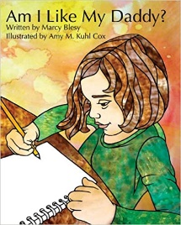 | 5-11 yrs | Join seven-year-old Grace on her journey through coping with the loss of her father while learning about the different ways that people grieve the loss of a loved one. In the process of learning about who her father was through the eyes of others, she learns about who she is today because of her father’s personality and love
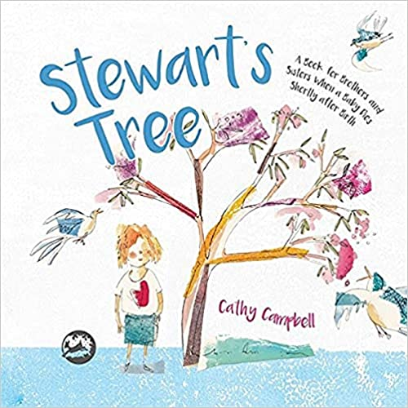 | 5-11 yrs | Ellen wondered if Stewart had gone to the moon in his spaceship...'  Ellen's new baby brother Stewart has been 'lost'. Ellen looks in all the cupboards for Stewart, and even in the washing machine - then her family help her understand that Stewart has died and isn't going to come back. Together they plant a tree for Stewart, so they will always have a place to remember him.
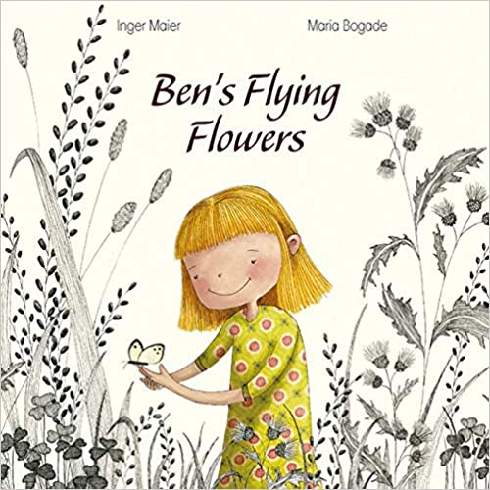 | 5-11 yrs | Ben's Flying Flowers follows Emily as she tries to overcome her grief following her brother's death. As time passes, Emily finds a way to remember her brother and grows to understand that although Ben has died, her happy memories of him can continue to live on.
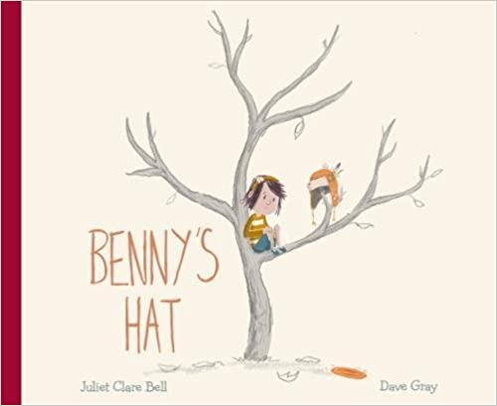 | 5-11 yrs | Benny’s Hat deals quietly with the huge subject of a sibling dying, from the viewpoint of the sister. It shows how children and young people might deal with serious illness and death differently to adults. The story gives adult readers examples of how to support children when a sibling is not expected to live, not only from the section for parents at the back, but also by watching Friz’s parents’ reactions to her behaviour.
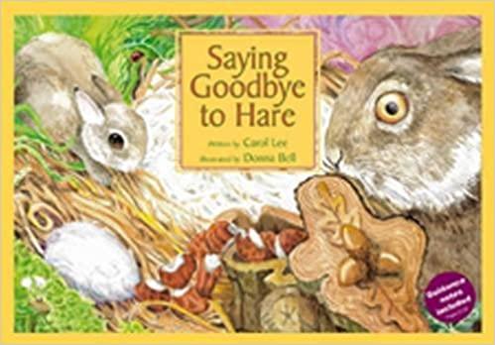 | 5-9 yrs | A beautifully illustrated story for children aged 5-9 years about young Rabbit who witnesses the life, illness and death of his dear friend Hare. The story is full of honesty and warmth and explores some of the feelings and questions children have at this time.
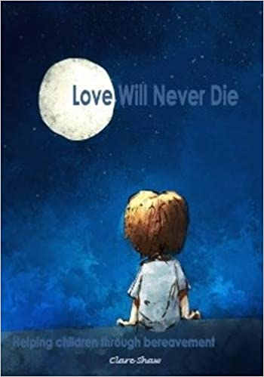 | 5+ yrs | Following the death of a loved one, it is vital that children have the opportunity to grieve. Using direct but child-friendly language, this book addresses the mixed emotions felt by a child during that process. It offers support and understanding alongside areas where the child can express themselves through writing and drawing.
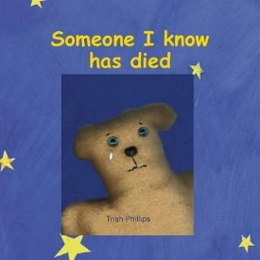 | 4-11 yrs | An innovative activity book with many unusual and interactive features, written for bereaved children to help them understand what it means when someone dies and to explore their thoughts and feelings with an adult. Although designed with primary-aged children in mind, some older children may also enjoy this book.
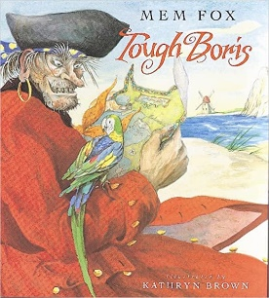 | 2+ yrs | Boris von der Borch is a mean, greedy old pirate--tough as nails, through and through, like all pirates. Or is he? When a young boy sneaks onto Boris's ship, he discovers that Boris and his mates aren't quite what he expected.
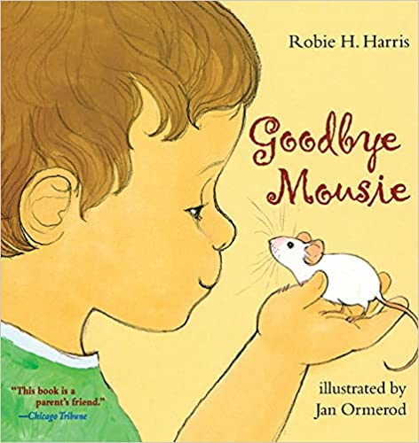 | 2-5 yrs | One morning a boy finds that his pet, Mousie, won't wake up. The truth is Mousie has died. At first the boy doesn't believe it. He gets very mad at Mousie for dying, and then he feels very sad. But talking about Mousie, burying Mousie in a special box, and saying good-bye helps this boy begin to feel better about the loss of his beloved pet.
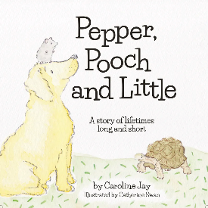 | 4-7 yrs | This is the story of Pepper the hamster, Pooch the puppy and Little the tortoise. They are friends for life, whether life is long or short.  Talking to children about death is not easy. This picture book for 4+ year olds offers a gentle introduction to life and death and the importance of the memories that link them, opening a door on a difficult subject.
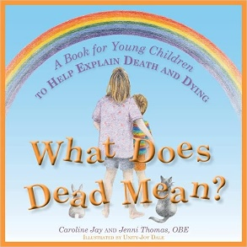 | 4-7 yrs | What Does Dead Mean? is a beautifully illustrated book that guides children gently through 17 of the 'big' questions they often ask about death and dying.  Questions such as 'Is being dead like sleeping?', 'Why do people have to die?' and 'Where do dead people go?' are answered simply, truthfully and clearly to help adults explain to children what happens when someone dies. Prompts encourage children to explore the concepts by talking about, drawing or painting what they think or feel about the questions and answers.
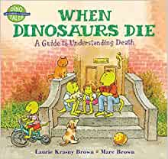 | 4-8 yrs | No one can really understand death but to children, the passing away of a loved one can be especially perplexing and troublesome. This is true whether the loss is a classmate, friend, family member or pet. Here to offer advice and reassurance from some very wise dinosaurs. This succinct and thorough guide helps dispel the mystery and negative connotations associated with death, providing answers to some of the most-often asked questions and also explores the feelings we may have regarding the death of a loved one and the ways to remember someone after he or she has died.

